2024 Sip ‘n’ Shop & Silent Auction
Sponsorship Commitment Form

Return this form with the bottom section completed to the Library at the address below.

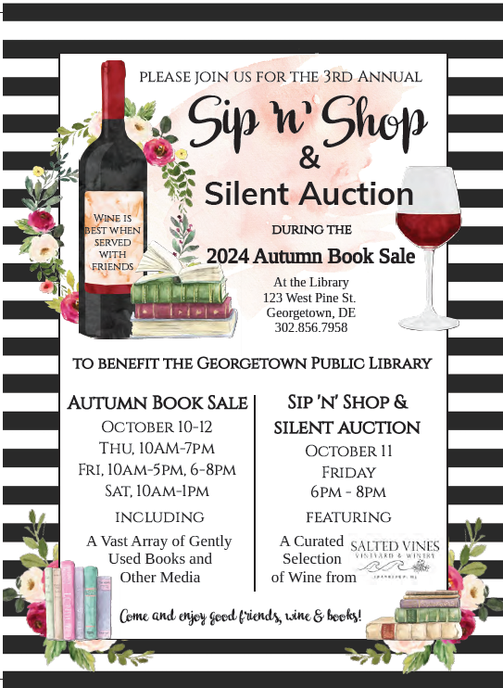 | Gold Sponsor  $1,000  Includes up to two (2) minutes on the microphone at the event to address attendees, exhibit table at the event, recognition on promotional material, company logo and website link on the website, company logo on yard sign and social media posts, signage at the event.  Silver Sponsor  $500  Includes exhibit table at the event, recognition on promotional material, listing on the website and social media posts, signage at the event.

Silent Auction Donations are also needed! What amazing service or items could you also donate to this event? Contact Marianne Poe, Event Director, at mkpoe1551@gmail.com.

Let us know what it will take for you to say, “YES!” to a sponsorship of this event today!
Make checks payable to “The Friends of the Georgetown Public Library” by August 1, 2024,
to ensure your name/logo will be on all printed materials per the packages below. *

2024 Sip ‘n’ Shop Sponsorship Commitment: YES! Sign us up!

Sponsor’s Name
(as you wish it to appear on signage)
Mailing Address
Contact Person
Phone |  |  | Email

Sponsorship Level | - Gold | - Silver | - Other amount:

Please send completed forms and check to: Friends of the Georgetown Public Library
123 West Pine St, Georgetown, DE 19947

